Semester 3 individual project

S3-S-CB-03

Onea Bianca

Google Lighthouse Report

January 14, 2022

# 1. OVERALL STATS

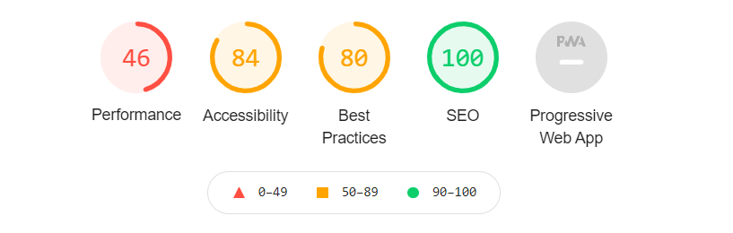

# 2. PERFORMANCE

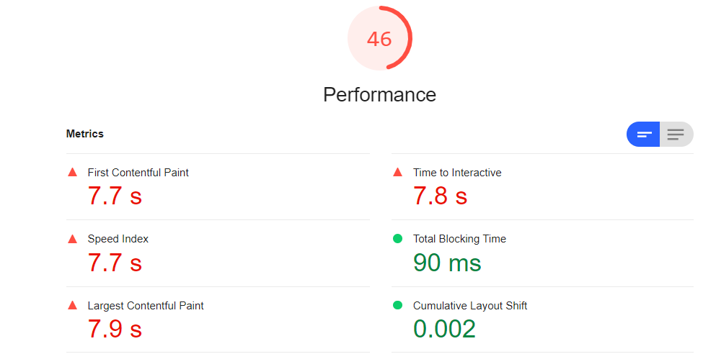

# 3. ACCESSIBILITY

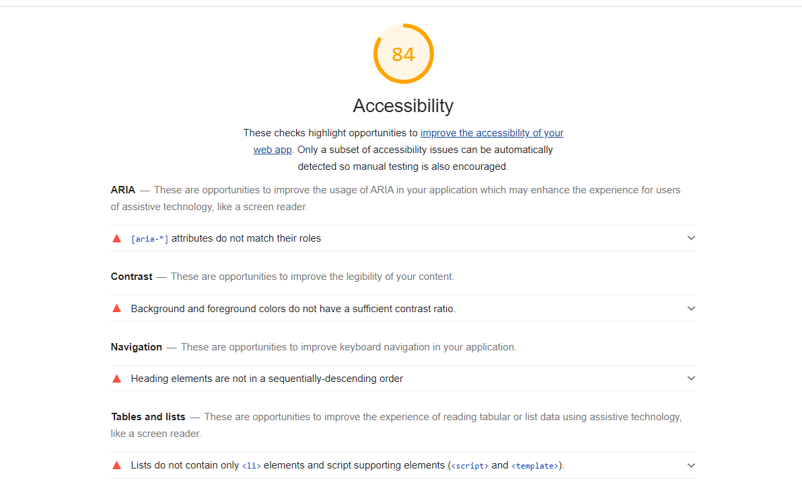

# 4. BEST PRACTICES

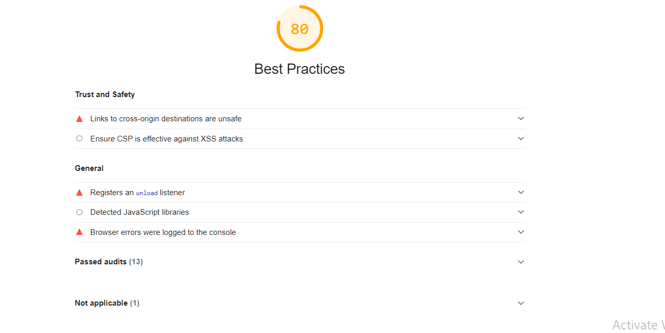

# 5. SEO

